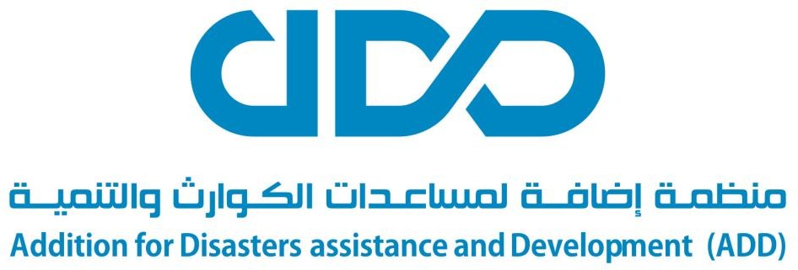

Addition for Disasters assistance and Development (ADD) is a non-governmental organization founded in 2016, headquartered in Khartoum. At ADD, we envisage a world free of poverty where people, especially women and children, live independently and with dignity; and where survivors of and people affected by disasters and crises receive life-saving assistance.

Bid No: 00102- FY23

City: Al MANAQL DISTRICTS, GEZIRA STATE, SUDAN

Deadline: 20th Dec 2023

Description:

ADD Sudan- Khartoum-Red Sea
Joint Implementation Program for Rehabilitation of The Affected Houses and Schools from Flood in Al-Manaql Districts, Gezira State, in the Republic of Sudan for the year 2023/2024
Request for Proposal (RFQ)

Name of Tender:

Supervision and design review of
- 112 house: - The house unit build up area is about 32 m2 consist of two adjacent rooms and designed as load bearing wall system, the walls are from the cement hollow block and the roof is corrugated sheet , please for further information see attached folder Housing unit
- 112 latrines: -
- Primary school: - The school consist of class rooms, offices and designed as load bearing wall system, the walls are from the cement hollow block and the roof is concrete slab , for further information see attached folder Primary school
- Intermediate school: - :- The school consist of class rooms ,offices and designed as load bearing wall system, the walls are from the cement hollow block and the roof is concrete slab , for further information see attached folder intermediate school.

Tender Number: ADD-KRT-RFQ-0102.FY23

Deadline Submission date:
20/Dec . /2023 –11 :00 PM

Please submit your bid to this email only. add-tender@addorg.org

Dear Sir / Madam,
ADD Sudan is looking for Reputable vender to supervise the construction of the project including 112 houses, 112 latrines, one primary school and one intermediate school shown in Attachments at a competitive price and with high quality.

General Requirements
1. Must Be Registered to conduct the business and in compliance with federal governments tax regulations in Susan.
2. Experience supplying International Organizations, Non-Governmental Organizations, or large private companies will be an advantage.
3. ADD retains the right to reject, cancel, negotiate, amend, split and accept any offer, without consideration of the lowest offer.
4. This is an invitation to vendors and is not a promise or obligation that ADD will contract with suppliers through the submitted offers.
5. Relevant bid committee may request for physical samples of some items during evaluation process of bids

Payment Terms
- Quotation should remain valid for a period of at least fifteen (30) days from the submission closing date.
- Payment shall be made upon verification and acceptance of services according to contract Purchase order
Acceptance of Payment Terms
Do you accept the above payment terms?
- Yes
- No
Requested Information
The submission must include:
- Submission of RFQ including cost of consultancy and supervision service for the project
- Full legal address and contact details of the company
- Name of company’s official owner and copy of his/her ID & passport (if available)
- Copy of company registration certificate
- Copy of Tax Registration Certificate
- Reference from previous similar business experience with reference contact information.
- Bank account information.
- The vendor must read, sign & stamp the Attachment (2) related to ADD SUPPLIER CODE OF CONDUCT
Bid Requirements
Offers that do not meet the following will be automatically rejected regardless of price:
- Offer of the prices must be received through attached 1, 2,3 form RFQ with stamp and sign
- Offers must be received before the stated deadline.
- Offers must include all information requested above.
- Bids that include mistakes in calculations within the Bill of Quantities will be excluded from competition.
- Bids must be submitted through the email address for receiving bids or through ADD tender box in Madani office, House No 18, Block No 215 Hai Nassir, Street 18, Madani, Aljazera , Sudan
- Offers must be clean & clear. The vendor should sign and stamp next to handwritten corrections or corrections made with whiteout.
- Offers must be complete from all sides, signed, dated, and stamped on all pages.
- Please note that ADD will sign a long-term contract with the selected supplier, based on unit prices, while actual quantities will be determined through purchase orders that will be issued later with awarded vendor(s) per ADD actual needs
Delivery Instructions:
Complete and stamped and signed offer can be submitted by email to add-tender@addorg.org

- as PDF file. Email must indicate the number of tenders which is (ADD-KRT-RFQ-00102.FY23) or the offer will be excluded. The file should not exceed 15 MBs and the company biography should not exceed 10 pages.
- Complete and stamped and signed offer must be delivered in sealed envelope with tender number on (ADD-KRT-RFQ-00102.FY23) to ADD Sudan office located in House No 18, Block No 215 Hai Nassir, Street 18, Madani, Aljazera ,. Bids may also be submitted to ADD office in Madani

Contact us:

Website:
www.addorg.org

